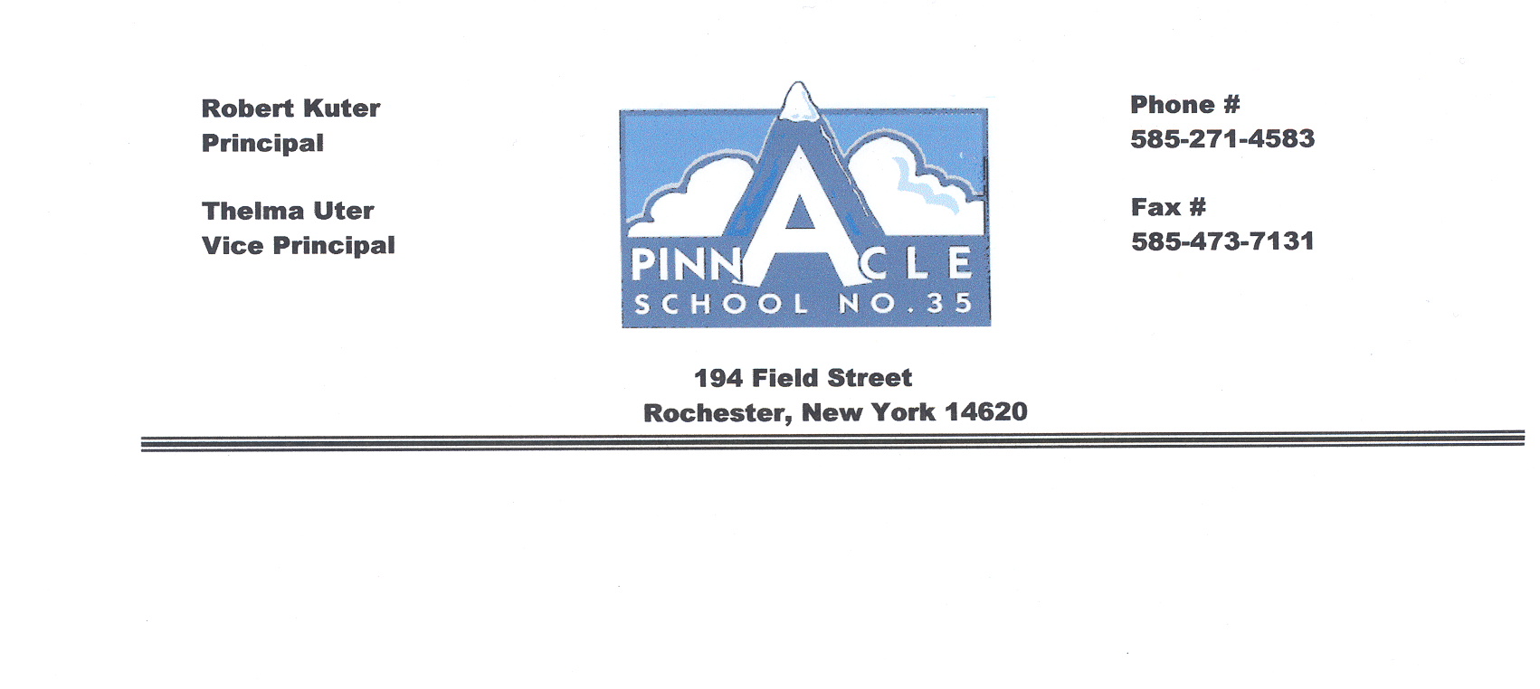**Pinnacle School #35**

(Use this form as a checklist, check and date boxes for your records)

**Behavior Intervention Process**

|  |
| --- |
| Student is demonstrating difficulty in class. |

|  |
| --- |
| **Look At Tier I**   * SWPBS with fidelity for all students   **✓** Student success – Continue Tier I Intervention.   * Differentiation Strategies being used * Present student to grade level for suggestions/ideas for differentiation * Meet with SWPBS team member |

|  |
| --- |
| Student continues demonstrating difficulty and has been written up and sent to office many times. |

|  |  |
| --- | --- |
| **Move to Tier II**  **Actions:**   * Fill out Intervention Referral Form * Send out STAR Consent Letter * Meet with Behavior Management Team to create a strategic Tier II Intervention * Review student’s cum for previous Interventions tried * Notify parents of concerns and your actions * Review data at with BMT (every 2 wks.) | **Tier II (4-6 wks.)**   * Strategic Interventions * Researched based in **addition to the universal systems set up by SWPBS** * Targeted to behavior * Progress monitoring two times a month (every other week) |

Student continues demonstrating difficulty **try another or change** Tier II intervention for another 4-6 weeks of data.

**✓** Student success – Continue Tier II

intervention.

|  |  |
| --- | --- |
| **Move to Tier III**  **Actions:**   * Read student cum * Organize student information, intervention, work samples (folder, binder, file) * Meet with BMT every week | **Tier III (4-6 wks.)**   * Intensive Interventions in **addition to the universal systems set up by SWPBS** * Increase time or intensity (every day for minimum 30-60 mins.) in addition to SWPBS * Individualized intervention designed by BMT and Classroom Teacher * *Weekly progress monitoring* |

Student continues demonstrating difficulty; Intervention Team will **try another or change** Tier III intervention for another 4-6 weeks of data.

**BMT**- Behavior Management Team

**✓** Student success – Continue Tier III

intervention.